Separate models

Exploration of relationships

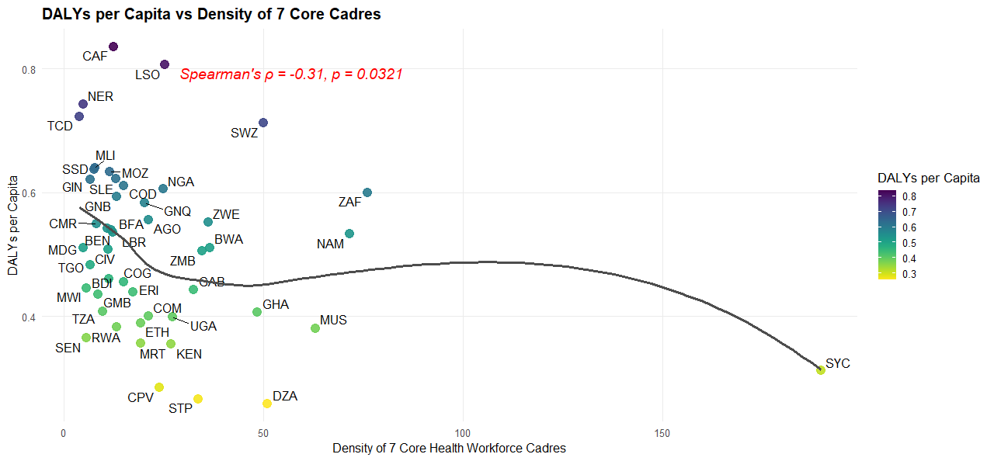

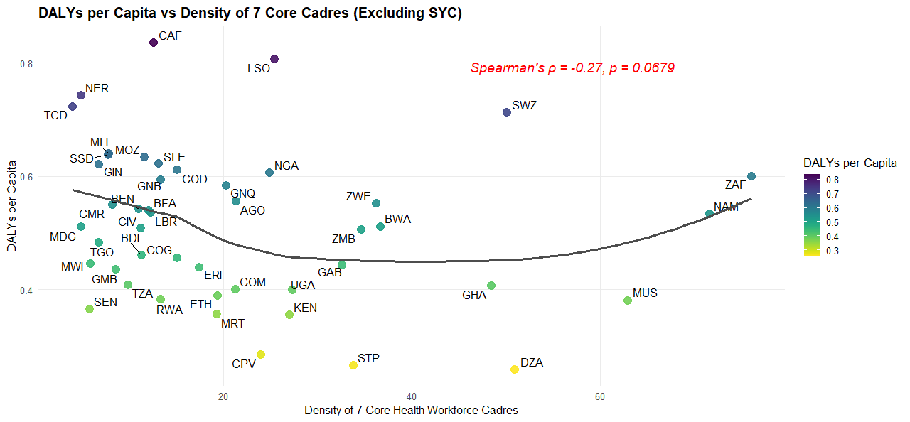

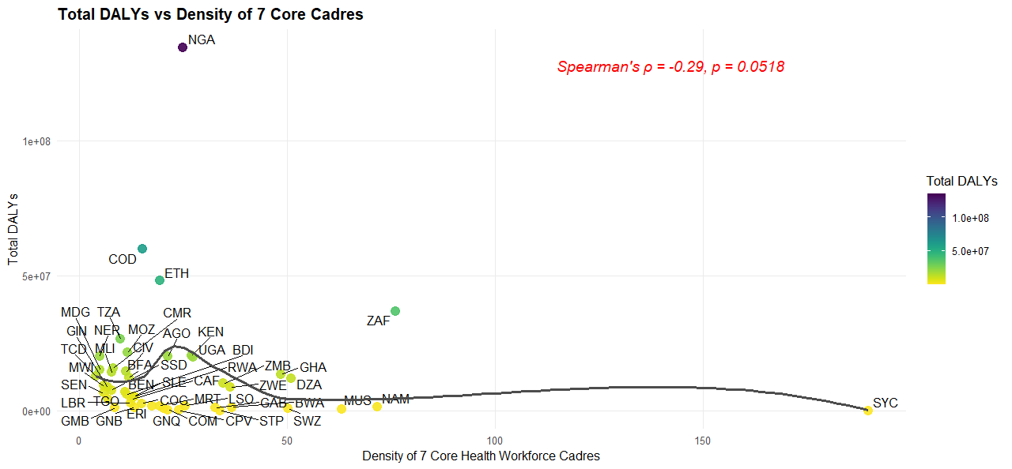

Note:
- Excluding one outlier in the name of SYC, introduces other outliers, and the opposite direction, leading to further weakening the power of the data.
- Total DALYS performs worse than the DALYs per capita, ofcourse, due to the effect of the population sizes.
- Therefore, all the data will be used, with DALYs per capita

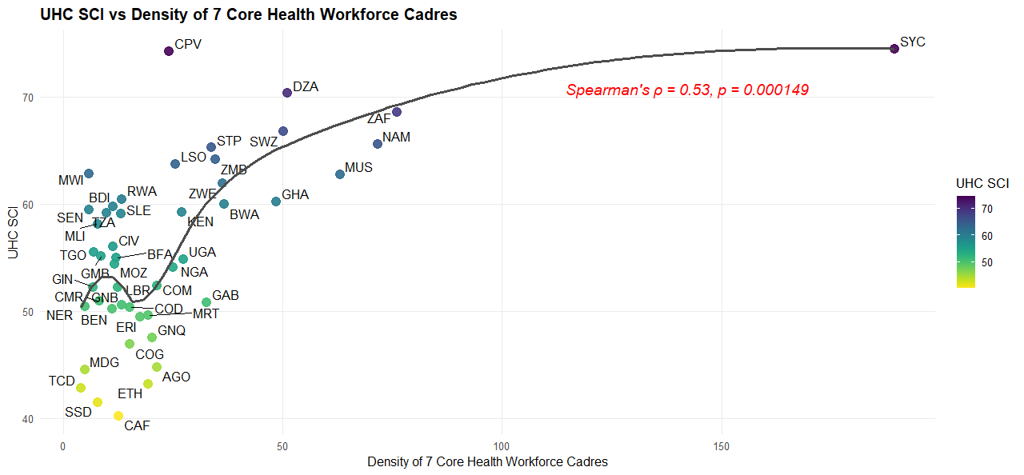

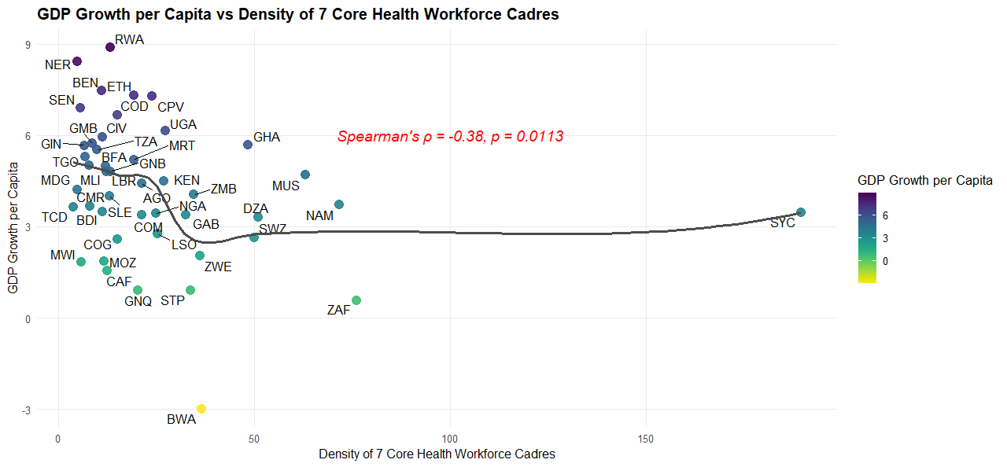

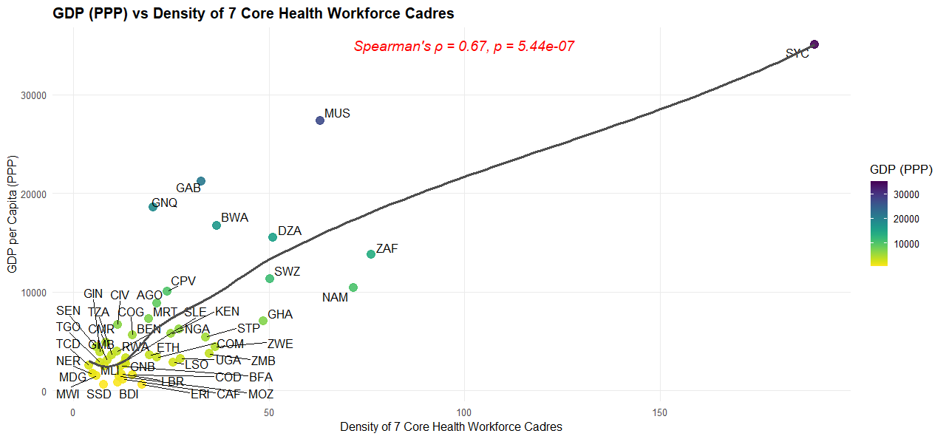

Note: The analysis will use GDP per capita instead of GDP growth per capita

More relationships

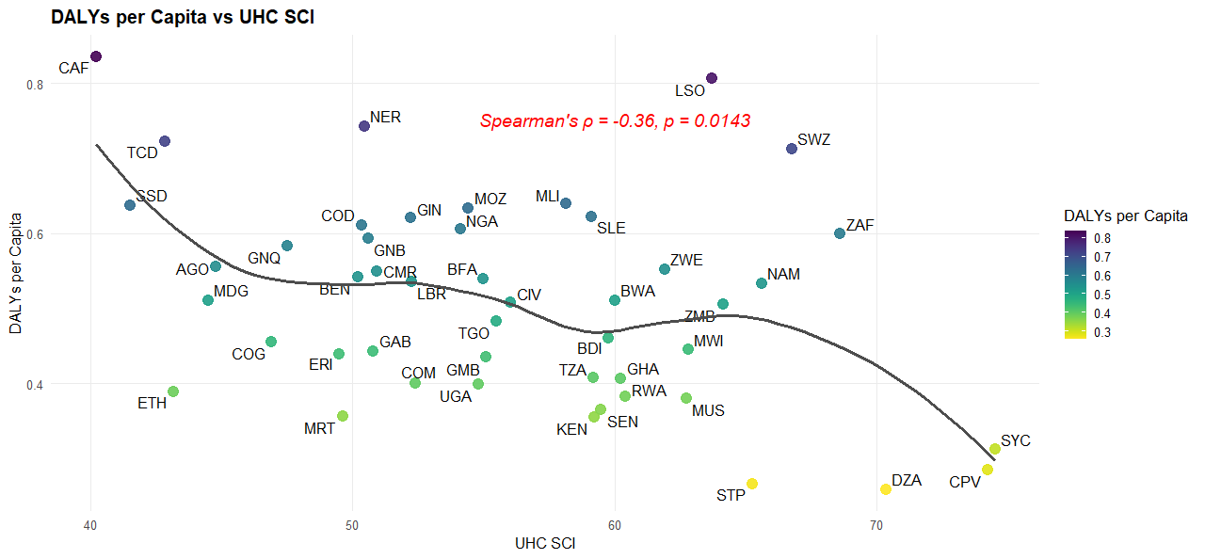

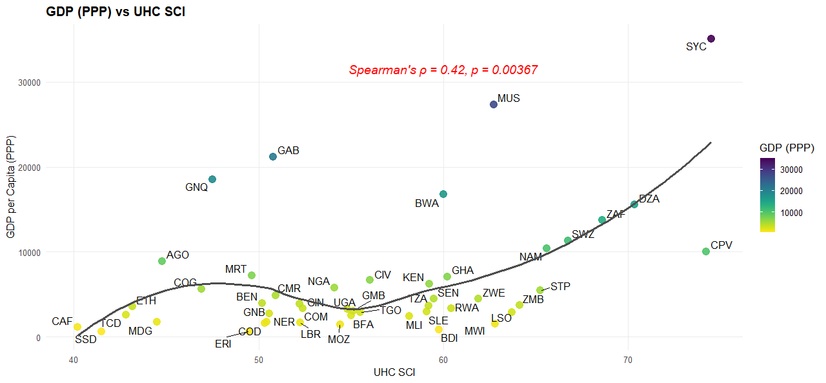

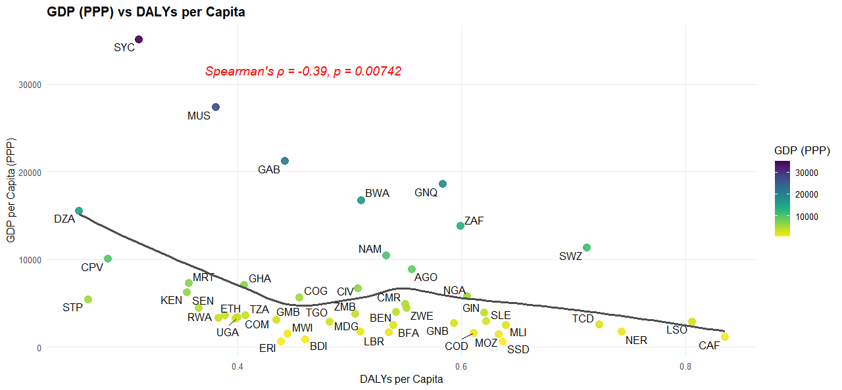

Notes
The relationships are all established, and it can be noted that the associations are non-linear rather than linear. Therefore, Generalized Linear Models (GLMs) will be explored.

Modelling
We perform separate models, holding all the intervening variables constant

- From HRH Density

Different models were tried
- The simple linear

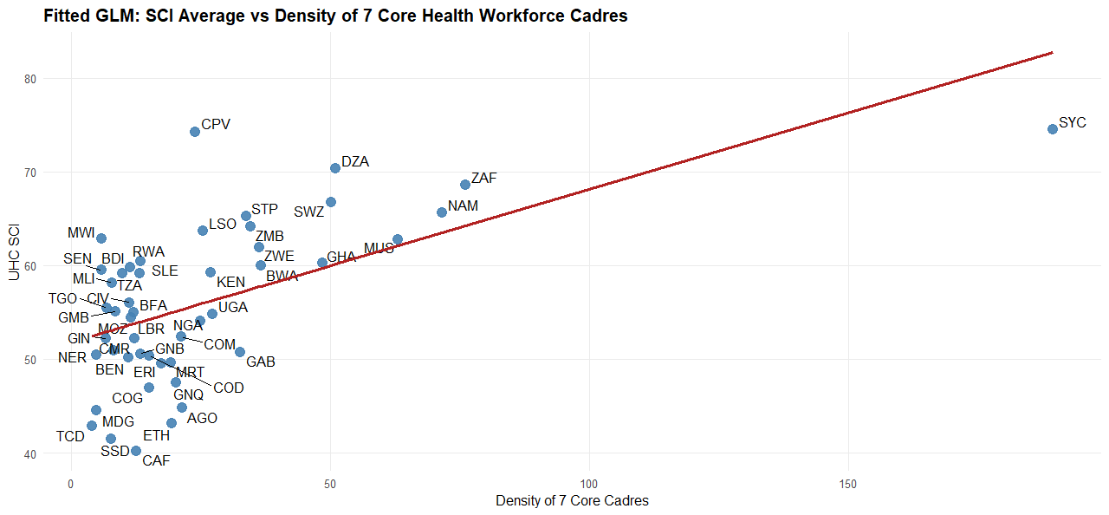

- The quadratic model

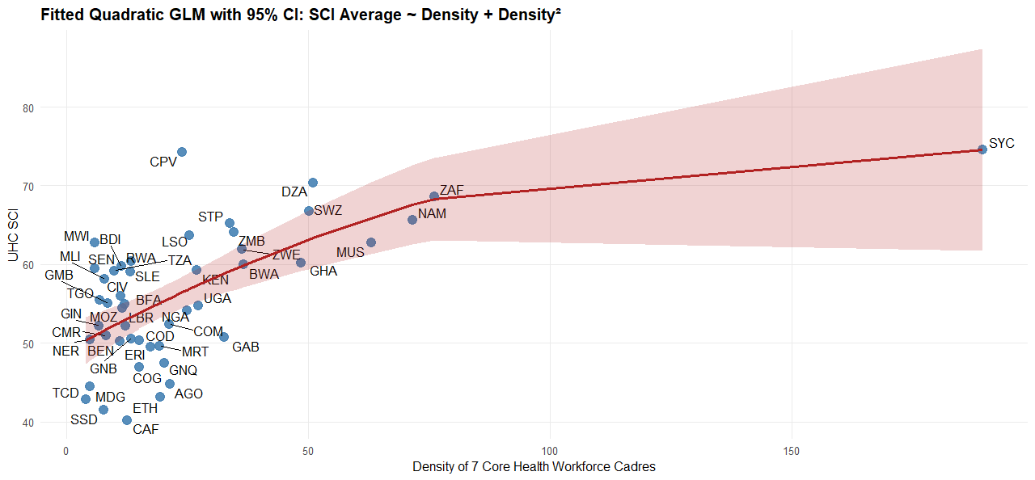

- The Log-transformed GLM (to capture diminishing returns)

This emerged to be the pragmatic model

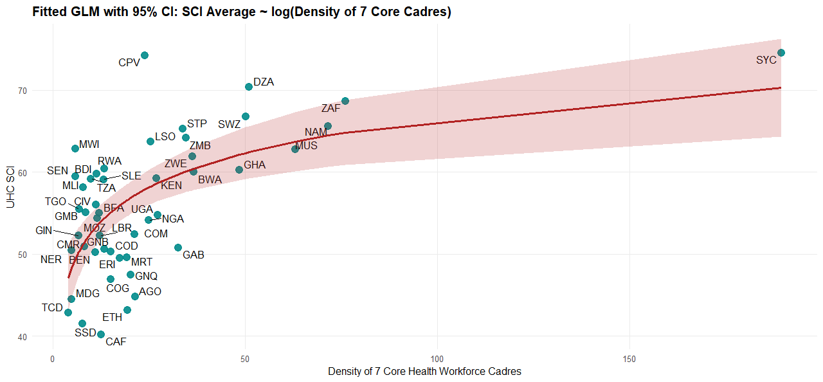

summary(glm_log)

Call:
glm(formula = SCI_Average ~ log(Density_7_cadres_2023), family = gaussian(link = "identity"),
data = glm_data)

Coefficients:
Estimate Std. Error t value Pr(>|t|)
(Intercept) 38.794 3.587 10.81 4.22e-14 ***
log(Density_7_cadres_2023) 6.009 1.204 4.99 9.52e-06 ***
---
Signif. codes: 0 ‘***’ 0.001 ‘**’ 0.01 ‘*’ 0.05 ‘.’ 0.1 ‘ ’ 1

(Dispersion parameter for gaussian family taken to be 46.14783)

Null deviance: 3225.6 on 46 degrees of freedom
Residual deviance: 2076.7 on 45 degrees of freedom
AIC: 317.43

Number of Fisher Scoring iterations: 2

The fitted model

SCI_Average = β₀ + β₁ × log(Density_7_cadres_2023) + ε
This transformation means that a proportional increase in workforce density (rather than an absolute one) is expected to improve SCI_Average.

Coefficients
Term | Estimate | Meaning
Intercept (38.79) | When log(density) is zero (i.e. density = 1), expected SCI_Average is 38.79
log(Density_7_cadres_2023) | 6.009 | Every unit increase in log(density) (≈ 2.7× increase in density) corresponds to a 6-point increase in SCI_Average
For example, increasing density from 10 to 27/10K (log change ≈ 1) leads to a predicted +6 in SCI_Average. That is, the log difference:
Initial density: 10 ⇒ log(10) ≈ 2.3026
Final density: 27 ⇒ log(27) ≈ 3.2958
Difference in log scale: ≈ 3.30 − 2.30 ≈ 1.0
Apply the coefficient:
SCI increase ≈ β₁ × Δlog(Density)
SCI increase ≈ 6.0 × 1.0 = +6.0 units

Model Fit & Diagnostics
- Residual deviance dropped from 3225.6 to 2076.7 — showing improvement over the null model.
- AIC (317.43) is slightly lower than your previous linear model, favouring this version on fit and parsimony.
- Dispersion (~46) remains comparable → residual spread is similar to your earlier model.

Statistical Significance
Both terms are highly significant (p < 0.001), confirming that workforce density (on a log scale) is a strong predictor of SCI performance.
Interpretation Insight
This model implies diminishing marginal returns: initial increases in density produce larger gains in SCI, while further increases yield smaller improvements. It aligns with systems thinking, where foundational investments unlock broad capacity, but saturation requires complementary strategies.

With DALYs

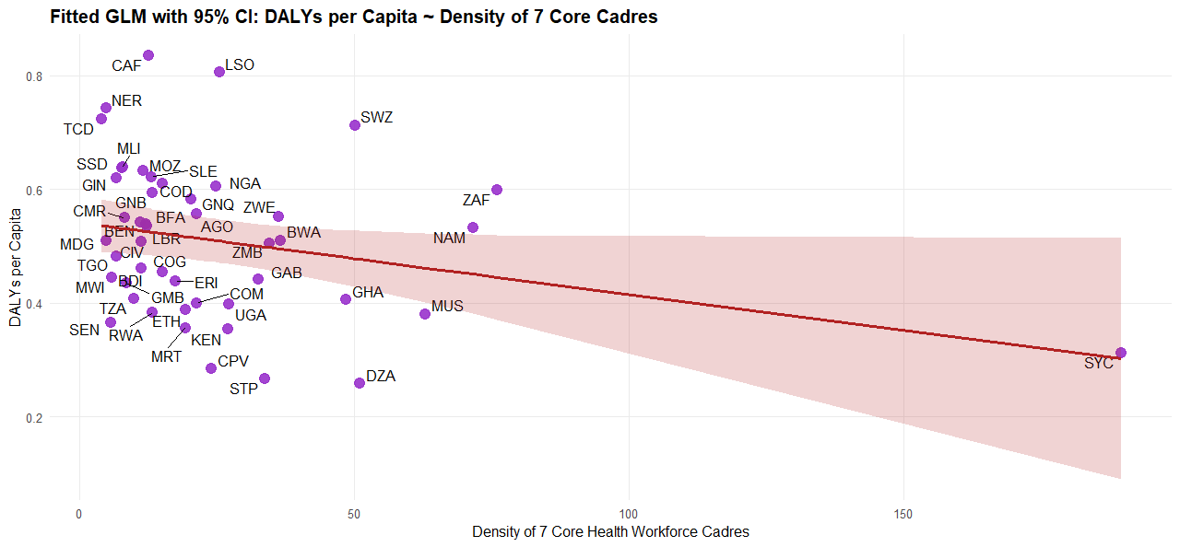

Log linear

summary(glm_log_dalys)

Call:
glm(formula = log(DALYS_2021_All.Causes.per.capita.) ~ Density_7_cadres_2023,
family = gaussian(link = "identity"), data = glm_data)

Coefficients:
Estimate Std. Error t value Pr(>|t|)
(Intercept) -0.638434 0.051442 -12.41 3.96e-16 ***
Density_7_cadres_2023 -0.002867 0.001309 -2.19 0.0338 *
---
Signif. codes: 0 ‘***’ 0.001 ‘**’ 0.01 ‘*’ 0.05 ‘.’ 0.1 ‘ ’ 1

(Dispersion parameter for gaussian family taken to be 0.07146263)

Null deviance: 3.5585 on 46 degrees of freedom
Residual deviance: 3.2158 on 45 degrees of freedom
AIC: 13.323

Number of Fisher Scoring iterations: 2

Model Equation
log(DALYS_2021_All.Causes.per.capita)=β0+β1⋅Density_7_cadres_2023+ϵ
This implies each unit increase in workforce density predicts a proportional reduction in DALY burden.

Coefficients
Term | Estimate | Interpretation
Intercept | –0.638 | Expected log(DALY per capita) when cadre density = 0 (theoretical baseline)
Density_7_cadres_2023 | –0.00287 | Each 1-unit increase in cadre density → approx. 0.29% reduction in DALYs per capita (since exp(–0.00287) ≈ 0.9971)
The negative coefficient confirms your hypothesis: more health workforce is associated with lower disease burden.

Variation Explained
To quantify how much variation the model explains:
# Manual pseudo R-squared calculation
R2 <- (3.5585 - 3.2158) / 3.5585 # Null deviance − Residual deviance / Null deviance
Result:
R² ≈ 0.096

So, the model explains ~9.6% of the variation in log(DALYs per capita). It's modest, but meaningful given the simplicity of the model and expected multi-factorial nature of DALY outcomes.
Model Fit
- Residual deviance reduced from 3.5585 → 3.2158
- AIC = 13.32 → solid benchmark for comparing with more complex alternatives (quadratic, multivariable, or log-log models)
- Dispersion ≈ 0.071 → tight residual variation

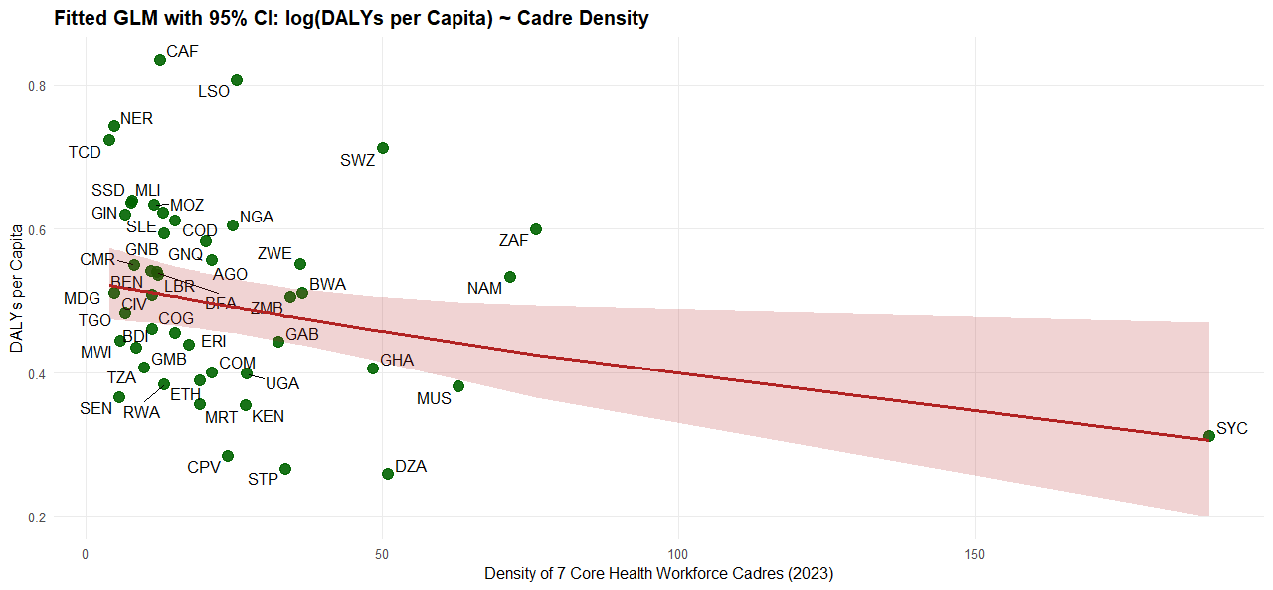

Gamma

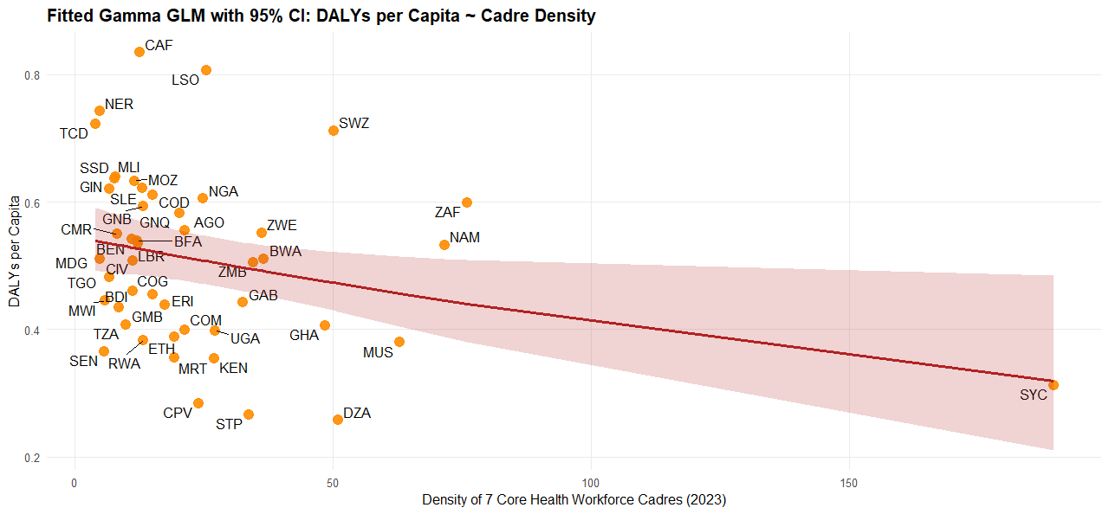

With GDP per capita

Linear

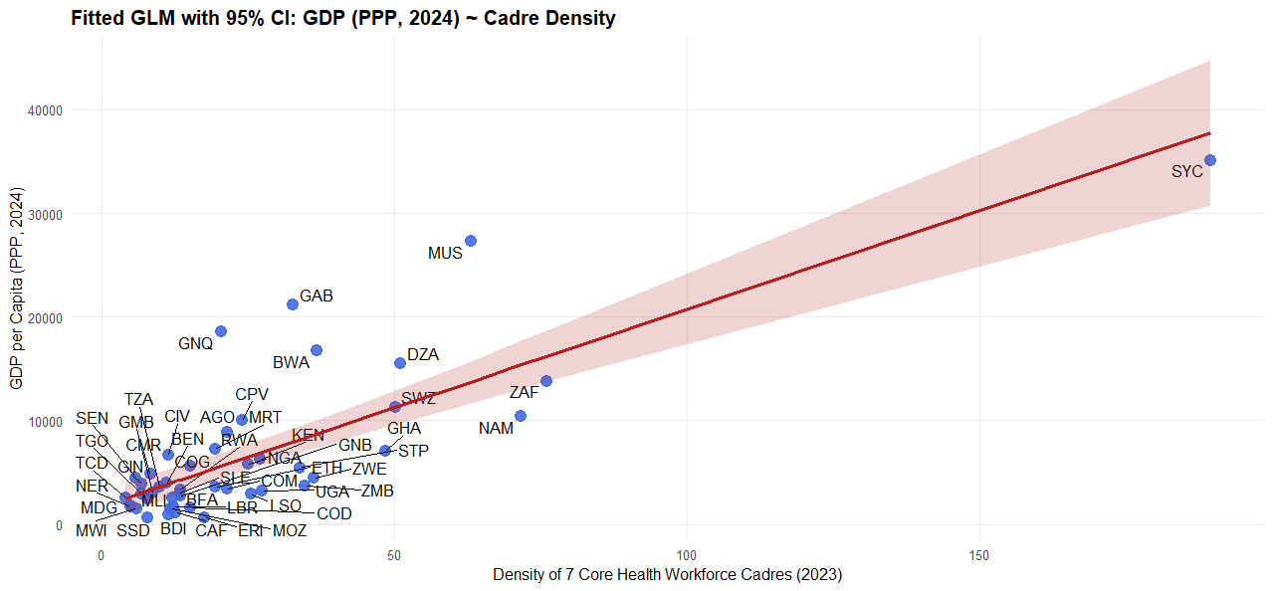

Log

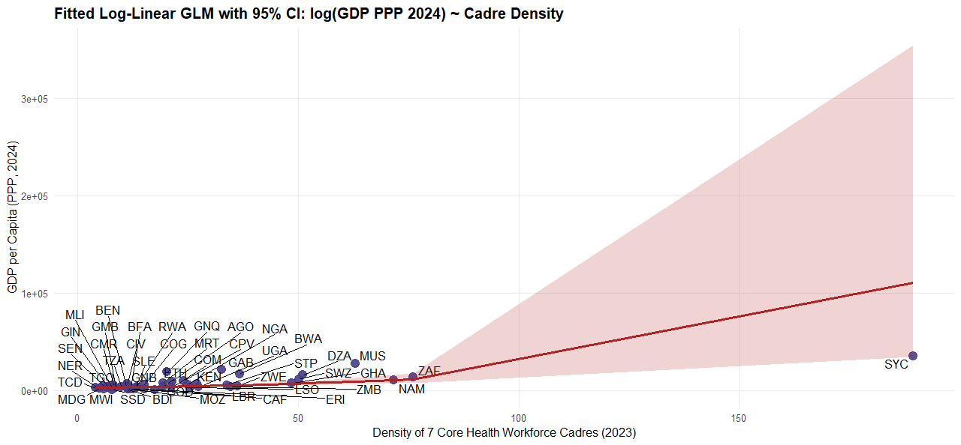

Gamma GLM

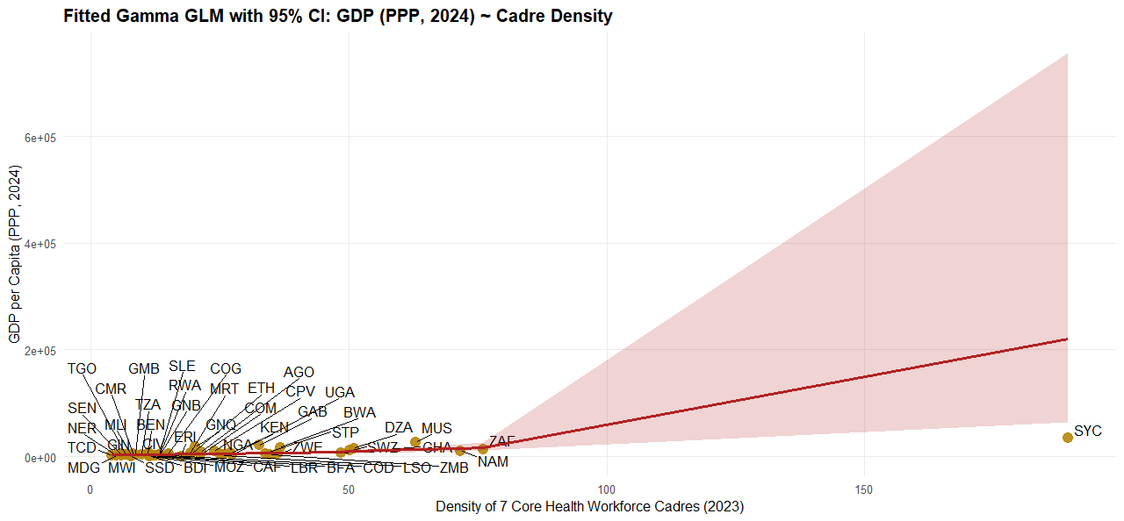

Log-log model

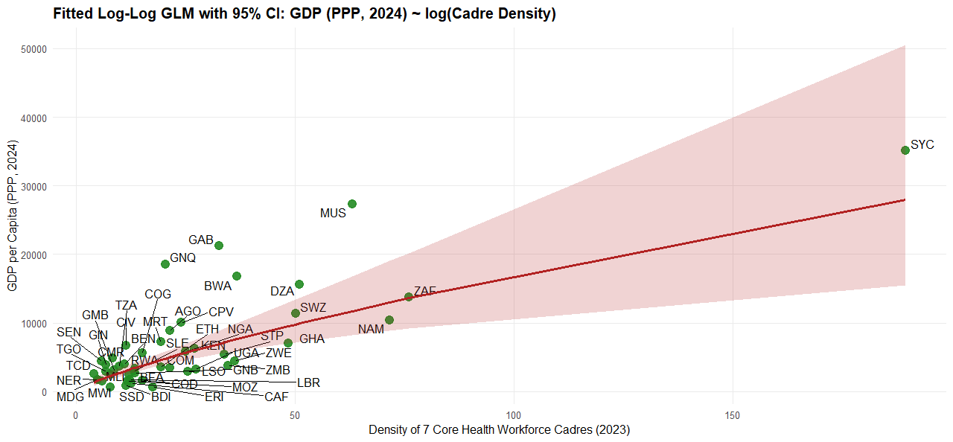

summary(glm_loglog_gdp)

Call:
glm(formula = log(GDP_PPP_2024) ~ log(Density_7_cadres_2023),
family = gaussian(link = "identity"), data = glm_data)

Coefficients:
Estimate Std. Error t value Pr(>|t|)
(Intercept) 6.0968 0.3572 17.068 < 2e-16 ***
log(Density_7_cadres_2023) 0.7897 0.1199 6.585 4.22e-08 ***
---
Signif. codes: 0 ‘***’ 0.001 ‘**’ 0.01 ‘*’ 0.05 ‘.’ 0.1 ‘ ’ 1

(Dispersion parameter for gaussian family taken to be 0.4576391)

Null deviance: 40.436 on 46 degrees of freedom
Residual deviance: 20.594 on 45 degrees of freedom
AIC: 100.6

Number of Fisher Scoring iterations: 2

Model Specification

This formulation lets you interpret coefficients as elasticities — i.e., the percentage change in GDP per capita associated with a 1% change in health workforce density.

Coefficients
Term | Estimate
Intercept (6.097) | Base level of log(GDP) when log(Density) = 0 (i.e., Density = 1)
log(Density) = 0.790 | A 1% increase in cadre density is associated with a ~0.79% increase in GDP per capita
For example, doubling the cadre density (i.e., 100% increase) predicts an approximate 79% increase in GDP per capita, assuming other factors remain constant.

Model Fit
- Residual deviance dropped from 40.44 → 20.59 → solid explanatory power
- R²-like metric: ~49% of variance in log(GDP) explained by log(Cadre Density)
- AIC = 100.6 → useful for model comparison across specifications
- Dispersion (~0.46) shows moderate residual spread — within acceptable range

Strategic Implications
This model confirms that cadre density not only matters for health outcomes, but also scales economically. Its elastic effect on GDP makes it valuable for macroeconomic modelling, especially in policy dialogues around human capital, health labour force scaling, and inclusive growth.

- From Service coverage

To DALYs
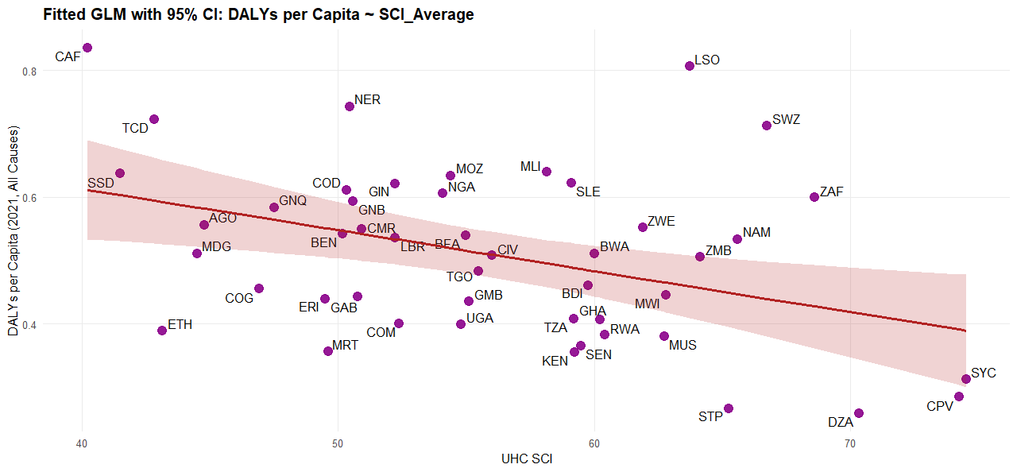

summary(glm_dalys_sci)

Call:
glm(formula = DALYS_2021_All.Causes.per.capita. ~ SCI_Average,
family = gaussian(link = "identity"), data = glm_data)

Coefficients:
Estimate Std. Error t value Pr(>|t|)
(Intercept) 0.872173 0.126068 6.918 1.35e-08 ***
SCI_Average -0.006486 0.002227 -2.912 0.00557 **
---
Signif. codes: 0 ‘***’ 0.001 ‘**’ 0.01 ‘*’ 0.05 ‘.’ 0.1 ‘ ’ 1

(Dispersion parameter for gaussian family taken to be 0.01599939)

Null deviance: 0.85566 on 46 degrees of freedom
Residual deviance: 0.71997 on 45 degrees of freedom
AIC: -57.018

Number of Fisher Scoring iterations: 2

Model Equation
Coefficients Explained
Term | Estimate | Meaning
Intercept | 0.872 | Expected DALYs per capita when SCI_Average = 0
SCI_Average | –0.00649 | Each 1-point increase in SCI_Average is associated with a 0.0065 reduction in DALYs per capita
For example, if a country improves its SCI score from 60 to 70, predicted DALYs drop by ≈ 0.065 per capita — a meaningful shift given most DALY per capita estimates lie in the subunit range.

Model Fit
- Residual deviance decreased from 0.8557 → 0.71997
- Pseudo R² = (0.85566 – 0.71997) / 0.85566 ≈ 15.9% of variation explained
- AIC = –57.02, indicating good parsimony and fit given the sample size and variance
- Dispersion ~ 0.016 → tight residual spread; solid homoscedasticity

Statistical Significance
- SCI_Average coefficient is significant (p = 0.0056)
- This confirms SCI is an independent predictor of DALYs per capita in your sample

Strategic Implication
This model supports framing SCI investments as a pathway to reducing disease burden.

To GDP per capita
Linear
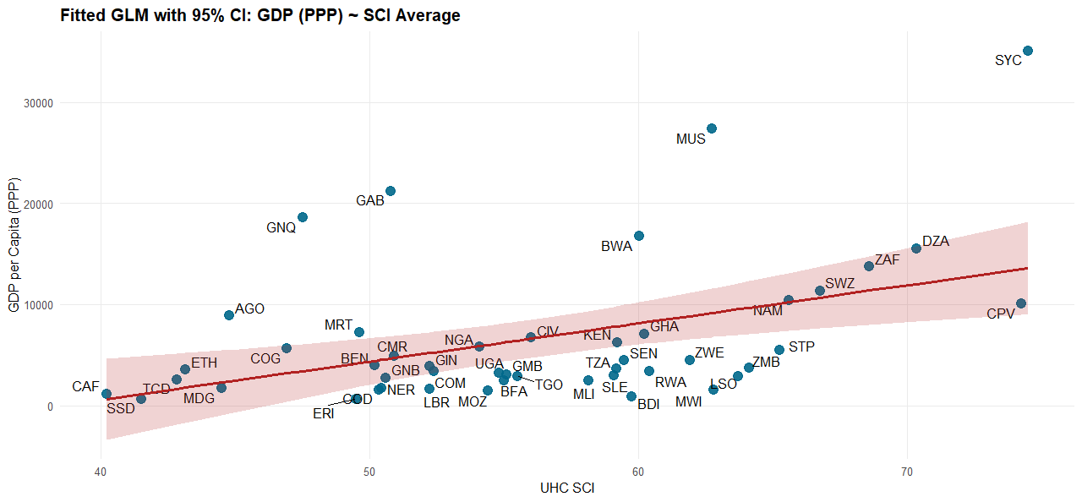

Log linear

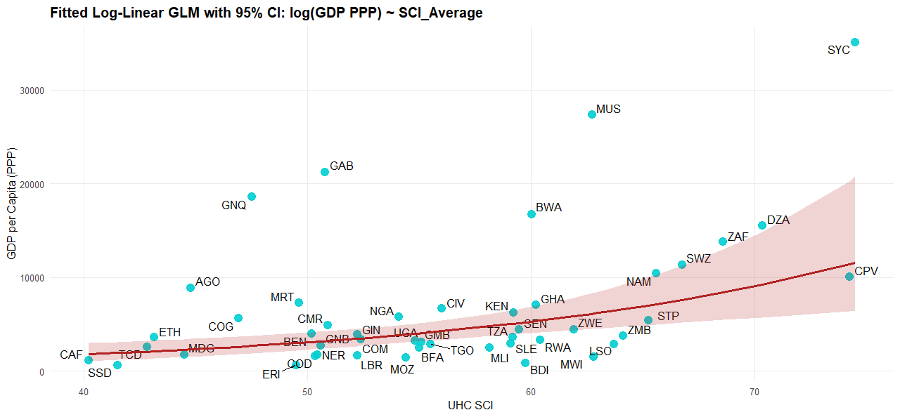

> summary(glm_log_gdp_sci)

Call:
glm(formula = log(GDP_PPP_2024) ~ SCI_Average, family = gaussian(link = "identity"),
data = glm_data)

Coefficients:
Estimate Std. Error t value Pr(>|t|)
(Intercept) 5.33106 0.82742 6.443 6.85e-08 ***
SCI_Average 0.05405 0.01462 3.697 0.00059 ***
---
Signif. codes: 0 ‘***’ 0.001 ‘**’ 0.01 ‘*’ 0.05 ‘.’ 0.1 ‘ ’ 1

(Dispersion parameter for gaussian family taken to be 0.6892001)

Null deviance: 40.436 on 46 degrees of freedom
Residual deviance: 31.014 on 45 degrees of freedom
AIC: 119.84

Number of Fisher Scoring iterations: 2

>

Model Specification
This structure interprets changes in SCI_Average as having multiplicative effects on GDP.

Coefficients Explained
Term | Estimate | Interpretation
Intercept | 5.33 | When SCI_Average = 0, predicted log(GDP) ≈ 5.33 → implies GDP ≈ $207 (exp(5.33)) — theoretical baseline
SCI_Average | 0.054 | Each 1-point increase in SCI predicts a ~5.5% increase in GDP per capita (since exp(0.054) ≈ 1.055)

Model Fit & Diagnostics
- Residual deviance reduced from 40.436 → 31.014
- ⇒ pseudo R² ≈ 23.3% of variation in log(GDP) explained
- AIC = 119.84 → used to compare fit across alternate models
- Dispersion = 0.689 → acceptable spread for Gaussian family

Statistical Significance
Both terms are highly significant:
- Intercept (p < 1e–7) confirms a stable baseline
- SCI_Average (p = 0.00059) confirms a reliable economic signal

Stronger service coverage, captured by SCI, is robustly linked to greater economic productivity.

Quadratic

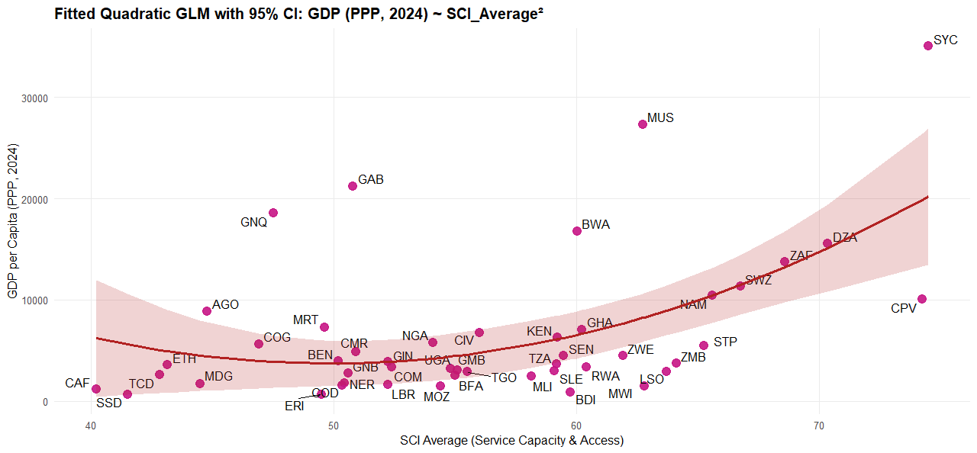

Gamma with log link

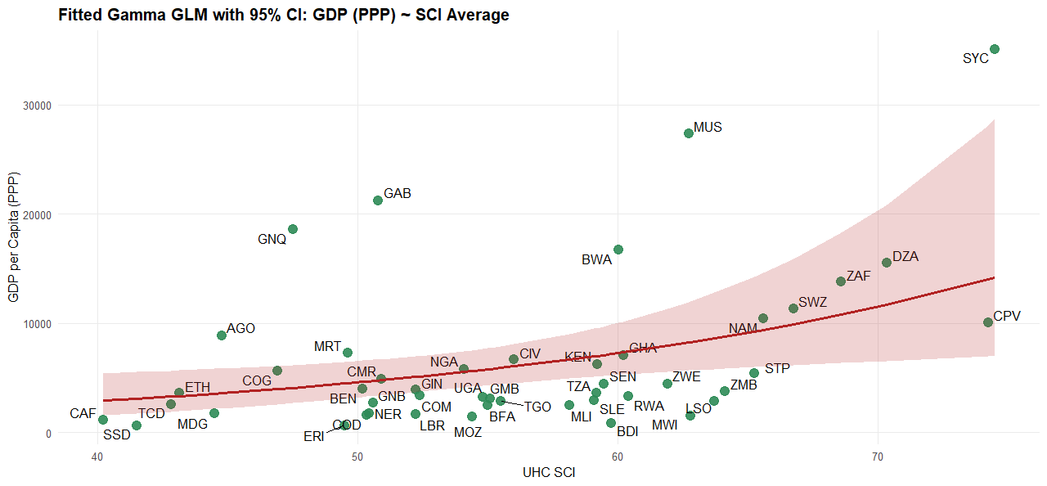

- From DALYs to GDP

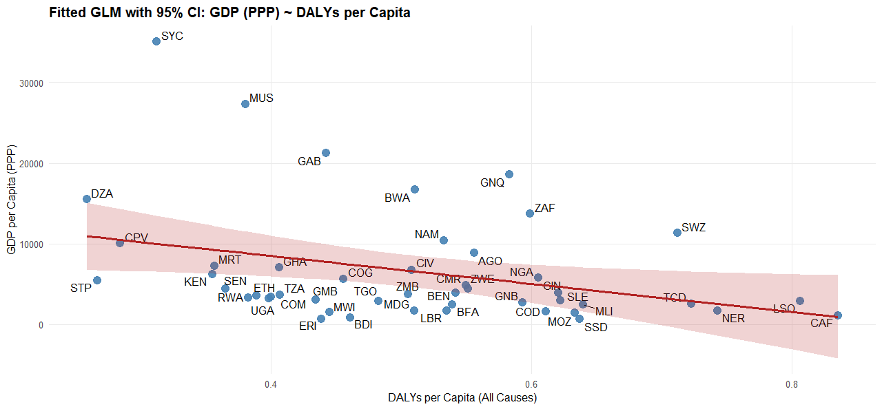

Log linear

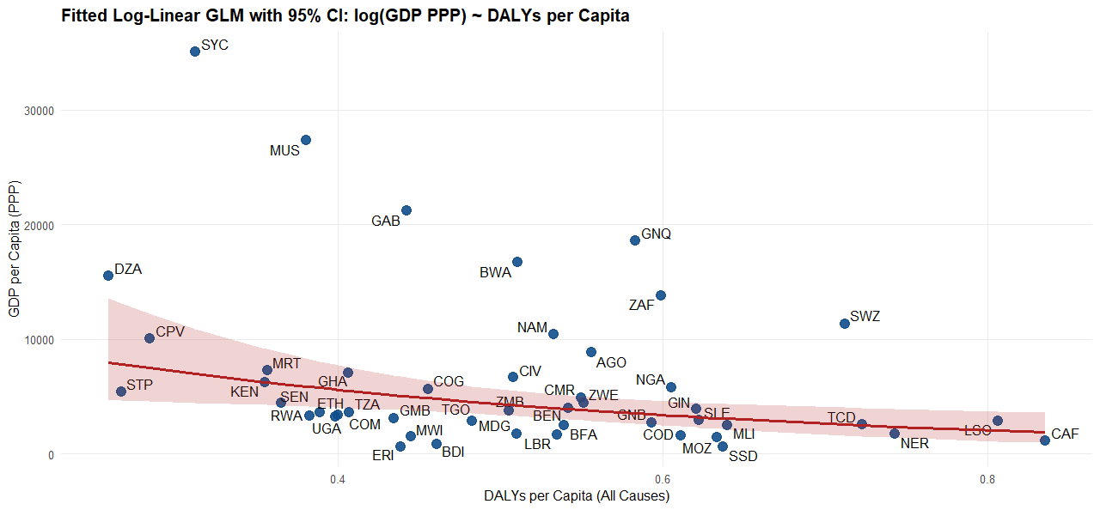

Log log link model

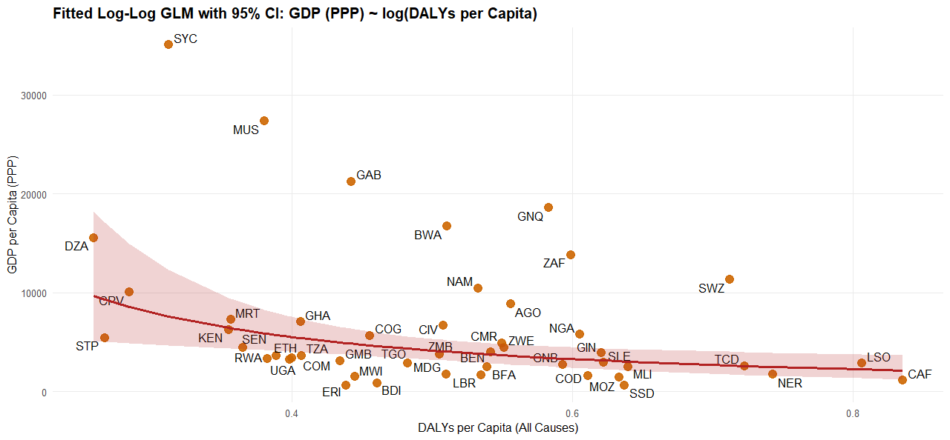

summary(glm_loglog_gdp_dalys)

Call:
glm(formula = log(GDP_PPP_2024) ~ log(DALYS_2021_All.Causes.per.capita.),
family = gaussian(link = "identity"), data = glm_data)

Coefficients:
Estimate Std. Error t value Pr(>|t|)
(Intercept) 7.4486 0.3550 20.984 < 2e-16 ***
log(DALYS_2021_All.Causes.per.capita.) -1.2765 0.4651 -2.745 0.00867 **
---
Signif. codes: 0 ‘***’ 0.001 ‘**’ 0.01 ‘*’ 0.05 ‘.’ 0.1 ‘ ’ 1

(Dispersion parameter for gaussian family taken to be 0.7697065)

Null deviance: 40.436 on 46 degrees of freedom
Residual deviance: 34.637 on 45 degrees of freedom
AIC: 125.03

Number of Fisher Scoring iterations: 2

Model Equation

This form enables elasticity interpretation — each coefficient reflects a percentage change in GDP for a 1% change in DALYs.

Coefficients Explained
Parameter | Estimate | Meaning
Intercept | 7.4486 | Baseline log(GDP) when DALYs = 1 (i.e., log(1) = 0) ⇒ GDP ≈ $1,714 (exp(7.4486))
log(DALYs) | –1.2765 | A 1% increase in DALYs per capita is associated with a ~1.28% decrease in GDP per capita

Model Fit Diagnostics
- Residual deviance dropped from 40.436 → 34.637 ⇒ pseudo R² ≈ 14.3%
- AIC = 125.03 ⇒ lower is better for model comparison
- Dispersion ~ 0.77 ⇒ reasonably tight residual distribution
- Significance: DALY term is statistically significant (p = 0.0087)

This model supports your systemic narrative: population health is an economic asset. Reducing DALYs yields multiplicative returns on GDP, making disease burden reduction not just a health priority — but a macroeconomic imperative.

Gamma regression

